University Management System



Session 2021-2025

Project Report
Submitted To
Sir Laeeq Khan Niazi

Submitted By

Zoya Naveed 2021-CS-201

Department of Computer Science,
University of Engineering and Technology,
Lahore

CHAPTER 1
INTRODUCTION:
Welcome to the cutting-edge University Management System (UMS) app, a comprehensive and user-friendly platform designed to streamline and enhance the administrative and academic processes within a university setting. Developed with a focus on efficiency, accessibility, and user satisfaction, our UMS app caters to the needs of both administrators and students, providing a centralized hub for managing courses, assignments, notifications, results, and fees. This innovative solution is poised to revolutionize the way universities handle their day-to-day operations, fostering a more organized, transparent, and technologically advanced learning environment.
Key Features:
User-friendly Dashboard:
An intuitive and visually appealing dashboard for easy navigation.
Quick access to essential features for both administrators and students.
Admin Features:
Course Management:
Add new courses with detailed information, including course name, description, and faculty details.
Delete or modify existing courses to reflect the dynamic nature of academic offerings.
View a comprehensive list of all available courses for efficient management.
Notification Management:
Create and broadcast notifications to students, faculty, and staff members.
Delete outdated or irrelevant notifications to maintain clarity and relevance.
Assignment Management:
Upload assignments with specific details, deadlines, and associated courses.
Remove or update assignments as needed, ensuring accurate information for students.
Result Management:
Input and manage student results with a secure and efficient grading system.
Generate reports and analytics for a holistic view of academic performance.
Fee Management:
Track and manage student fees, including tuition, examination, and other miscellaneous fees.
Generate fee challans and provide a seamless payment experience for students.
Student Features:
Course Registration:
Browse and register for courses based on academic requirements and personal preferences.
Receive instant confirmation and updates on course registration status.
Notification Center:
Access a dedicated notification center to stay informed about important announcements, deadlines, and updates.
Customize notification preferences for a personalized experience.
Assignment Access:
Download assignments, view associated details, and submit completed tasks seamlessly.
Receive timely reminders and notifications about upcoming assignment deadlines.
Fees Challan:
View and download fee challans for a transparent breakdown of fees.
Stay updated on payment deadlines and receive alerts for overdue payments.
Results Dashboard:
Check and download academic results for a comprehensive overview of individual performance.
Access historical data for a detailed academic progression analysis.

CHAPTER 3
Project Management:
The project management was done on click up. The project was divided into 49 tasks. The total number of sprints were 7.
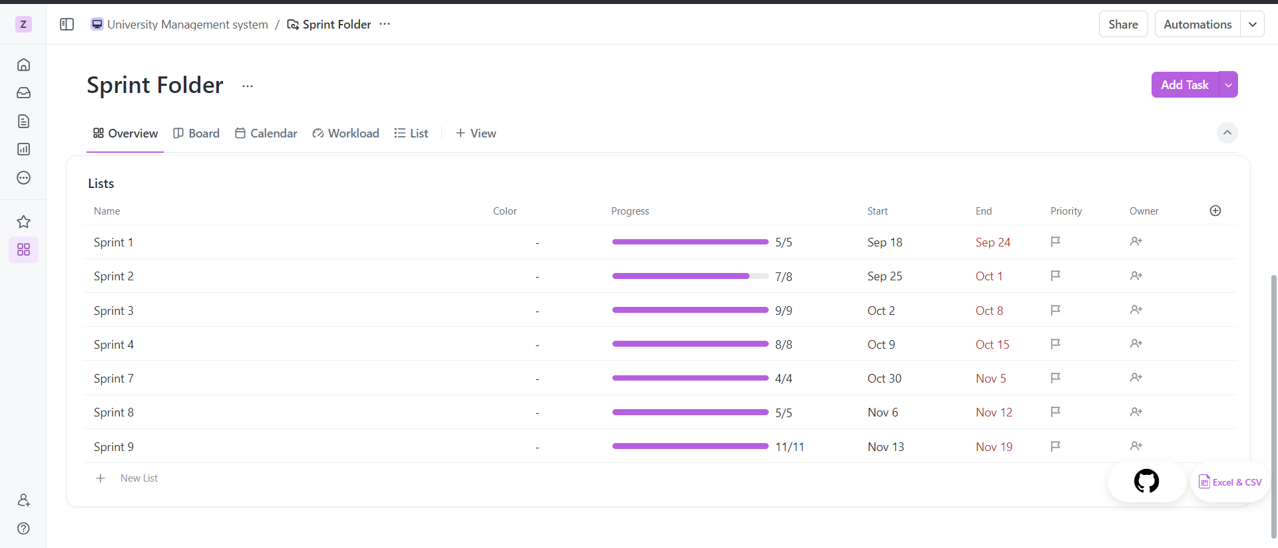
Communication with owner:
The communication with the owner was done over slack. From project features to regular updates everything was briefed to the owner extensively over a course of 2+ months.
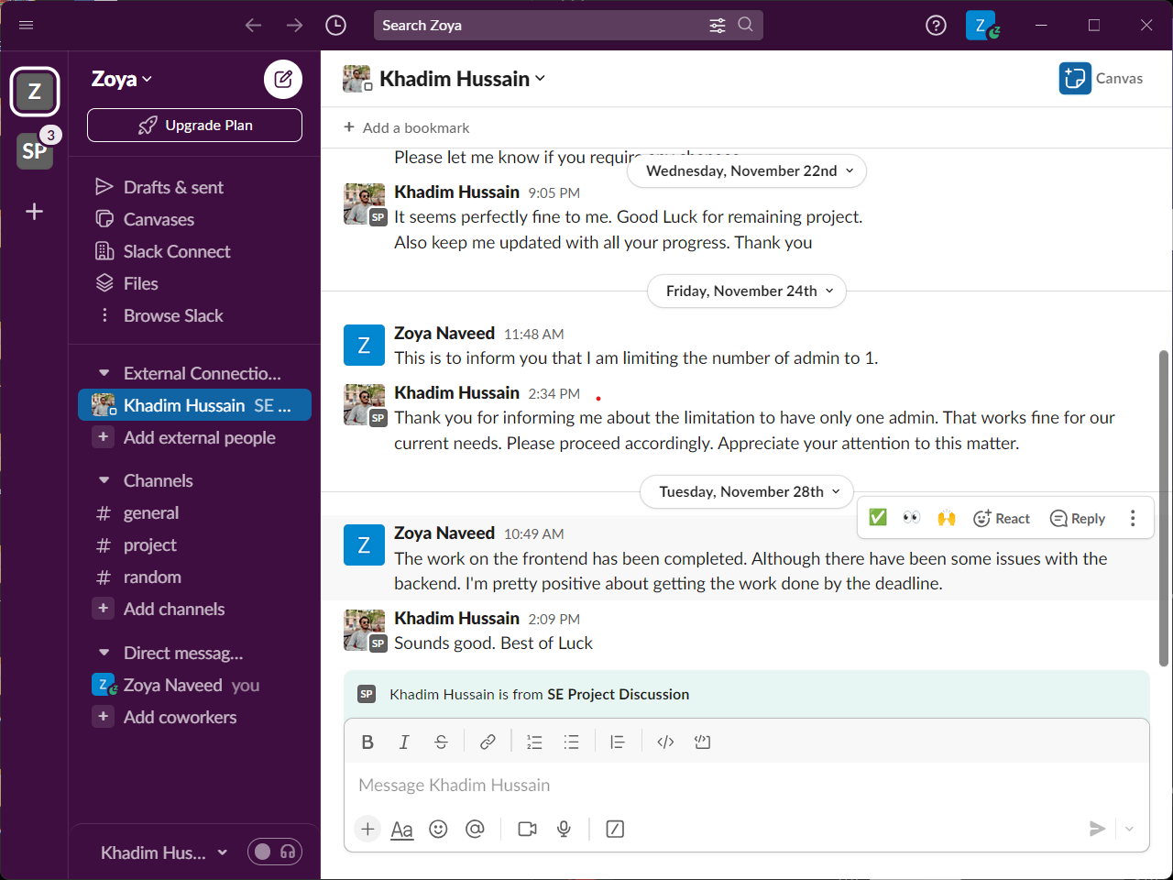

Meeting Minutes:
Meeting Number 1
Date: 9/14/2023 Time: 1:15
Project Title: University Management System
Members: Zoya Naveed/Khadim Hussain
Registration No | Name | Attendance/ Remark
2021-CS-201 | Zoya Naveed | Present
2021-CS-204 | Khadim Hussain | Present

Type of Meeting: Physical
Location: Lab 1, Computer Science Department, UET
Agenda:
- Detailed Discussion of the functional requirements
- Detailed discussion of the non-functional requirements
- Detailed discussion on user authentication
- Detailed discussion on Fee management
- Detailed discussion on the implementation Notification Board
- Discussion on the Management of the Database

Discussion or Feedback
Detailed discussion on the above-mentioned agendas. The client conveyed all the functional requirements properly and explained them in detail.
Few Key Points:
- All the admins will have the ability to alter user credentials.
- Establishment of user training and support(help) is required
- Unified login Page is required so that the user will not have to choose a role
- Report generation in PDF is expected
- The notification system should be implemented to notify users on time
Further Discussions are to be done on Slack.
Signature:

Owner
Khadim Hussain

Developer
Zoya Naveed

Meeting Number 2
Date: 11/6/2023 Time: 8:00
Project Title: University Management System
Members: Zoya Naveed/Khadim Hussain
Registration No | Name | Attendance/ Remark
2021-CS-201 | Zoya Naveed | Present
2021-CS-204 | Khadim Hussain | Present

Type of Meeting: Physical
Location: Google Meet
Agenda:
Talking about the User Interface and Features
Discussion or Feedback
Detailed discussion on the above-mentioned agendas. The client conveyed all the functional requirements properly and explained them in detail.
Few Key Points:
- Discussion ensued regarding any necessary adjustments to the UI to align it with the client's vision and expectations
- Detailed discussions were held on specific features, addressing questions or concerns from both parties
- Feedback was gathered during the demo, and any immediate adjustments or notes were documented.
Further Discussions are to be done on Slack.
Signature:

Owner
Khadim Hussain

Developer
Zoya Naveed

Meeting Number 3
Date: 11/15/2023 Time: 8:00
Project Title: University Management System
Members: Zoya Naveed/Khadim Hussain
Registration No | Name | Attendance/ Remark
2021-CS-201 | Zoya Naveed | Present
2021-CS-204 | Khadim Hussain | Present

Type of Meeting: Physical
Location: Google Meet
Agenda:
Project Demo Presentation and Feedback
Discussion or Feedback
Detailed discussion on the above-mentioned agendas. The client conveyed all the functional requirements properly and explained them in detail.
Few Key Points:
- The demonstration of the user interface showcased
- Performance metrics and testing results were discussed
- A timeline for the implementation of feedback was discussed and agreed upon.
- The deployment plan was briefly discussed, taking into account any additional client requirements
Further Discussions are to be done on Slack.
Signature
Owner
Khadim Hussain

Developer
Zoya Naveed

GITHUB:
We maintained version control using GitHub. The commits, commit style is as follows:
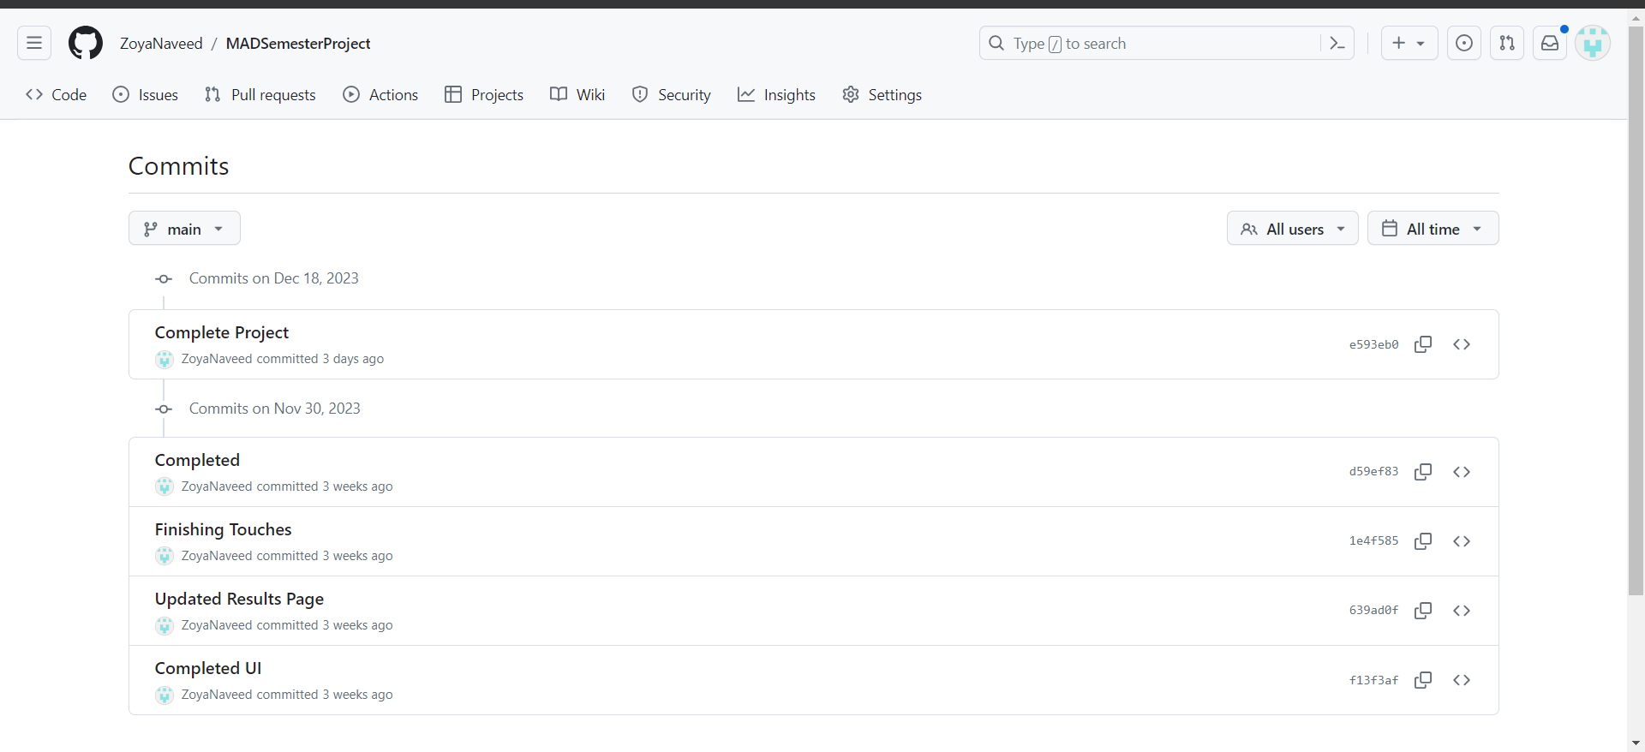

Technical Stack:
Flutter was chosen for the development of the University Management System (UMS) app due to its cross-platform capabilities, allowing for the creation of a single codebase for both Android and iOS. The framework's Hot Reload feature accelerates development cycles, fostering quick iterations and efficient debugging. Flutter's rich set of customizable widgets ensures a visually appealing and consistent user interface across diverse devices. Its performance benefits, open-source nature with strong community support, ease of learning Dart programming language, seamless backend integration, and adaptive UI capabilities make Flutter an ideal choice for creating a feature-rich and future-proof UMS app, ensuring a streamlined development process and a high-quality user experience.
Best Coding Practices:
Throughout the development of the University Management System (UMS) app, I rigorously adhered to best coding practices to ensure a robust and maintainable codebase. Employing a modular architecture, I organized the code into distinct components, promoting readability and reusability. Comprehensive code comments and documentation were integrated, offering insights into complex logic and facilitating collaboration among developers. Consistency in coding style, following established conventions, contributed to improved code readability and a unified development approach. Git version control was employed with meaningful commit messages and regular commits, facilitating seamless collaboration and issue resolution. I prioritized robust error handling mechanisms to gracefully manage exceptions and provide informative error messages. Optimizing database queries and implementing security measures, such as encryption and input validation, ensured performance and safeguarded sensitive data. Regular code reviews and testing strategies were integral to identifying and rectifying issues early, enhancing the overall reliability and functionality of the UMS app.

Project Structure:
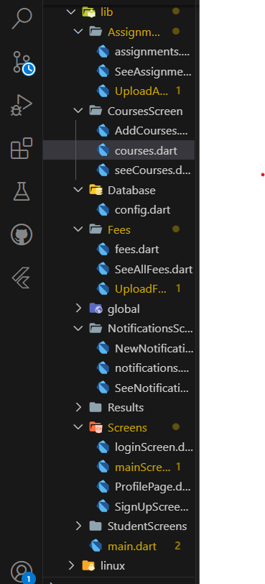
Code Review:
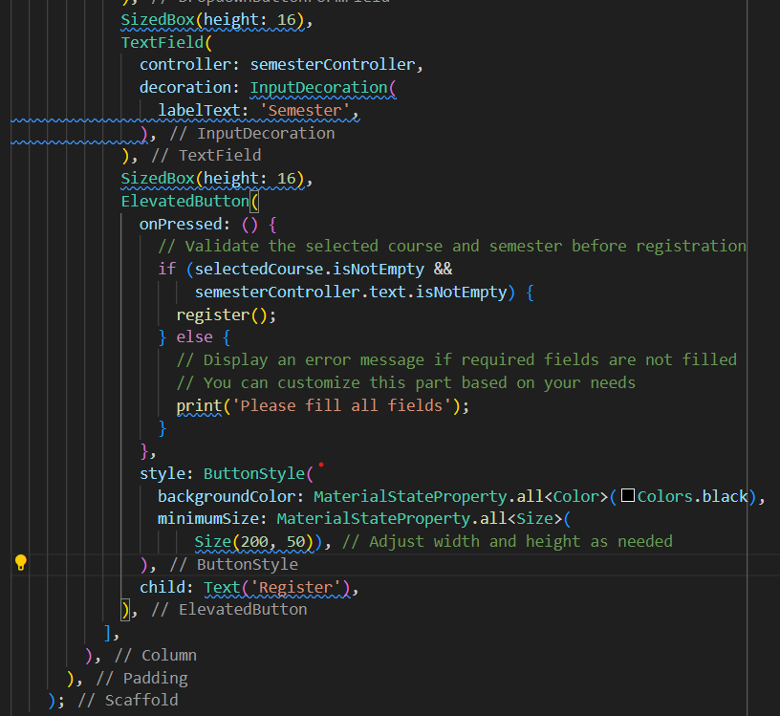

Database Design:
1. **User Authentication**:
- Table: `Users`
Fields:
- UserID (PK) INT
- Username STRING
- Password STRING
- CreatedAT → Date Time
- UpdatedAT → Date Time
- Active → Boolean
2. **Admin Management**:
- Table: `Admins`
Fields:
- AdminID(PK) INT
- UserID(FK to Users) INT
- FullName STRING
- Email STRING
- Phone STRING
- DOB. DATE TIME
- CreatedAT → Date Time
- UpdatedAT → Date Time
- Active → Boolean
7. **Course Management**:
- Table: `Courses`
- CourseID (PK)
- CourseCode INT
- CourseName STRING
- TeacherID (FK to Teachers)
- DepartmentID (FK to departments)
- CreditHours INT
- StartDate DATETIME
- EndDate DATETIME
- ClassID (FK to Classes)
- CreatedAT → Date Time
- UpdatedAT → Date Time
- Active → Boolean
8. **Teacher Assignment**:
- Table: `TeacherAssignments`
- AssignmentID (PK)
- TeacherID (FK to teachers)
- CourseID (FK to courses)
- ClassID (FK to classes)
- Year INT
- Semester INT
- Schedule VARCHAR
- CreatedAT → Date Time
- UpdatedAT → Date Time
- Active → Boolean
9. **Student Registration**:
- Table: `StudentRegistrations`
- RegistrationID (PK)
- Student (FK to students)
- Class (FK to Classes)
- RegistrationDate DATETIME
- RegistrationStatus String
- PaymentStatus STRING
- PaymentDate DATETIME
- CreatedAT → Date Time
- UpdatedAT → Date Time
- Active → Boolean
10. **Course Enrollment**:
- Table: `CourseEnrollments`
- EnrollmentID (PK)
- StudentID(FK to students)
- CourseID (FK to course)
- EnrollmentDate DATETIME
- EnrollmentStatus STRING
- FinalGrade STRING
- CompletionStatus VARCHAR
- UpdatedAT → Date Time
- CreatedAT → Date Time
14. **Fee Management**:
- Table: `Fees`
- FeeID(PK)
- StudentID (FK to students)
- FeeType STRING
- Amount INT
- DueDate DATETIME
- PaymentStatus STRING
- PaymentDate DATETIME
- CreatedAT → Date Time
- UpdatedAT → Date Time
- Active → Boolean

15. **Notifications**:
- Table: `Notifications`
- NotificationID(PK)
- Title STRING
- Content VARCHAR
- DateSent DATETIME
- Sender INT
- CreatedAT → Date Time
- UpdatedAT → Date Time
- Active → Boolean
17. **Grade Management**:
- Table: `Grades`
- GradeID (PK)
- StudentID (FK to student)
- CourseID (FK to course)
- Grade STRING
- DateRecorded DATETIME
- TeacherID (FK to Teacher)
- CreatedAT → Date Time
- UpdatedAT → Date Time
- Active → Boolean

18. **User Credential Management**:
- This is handled by the `Users` table.

CHAPTER 4
- Login Page:
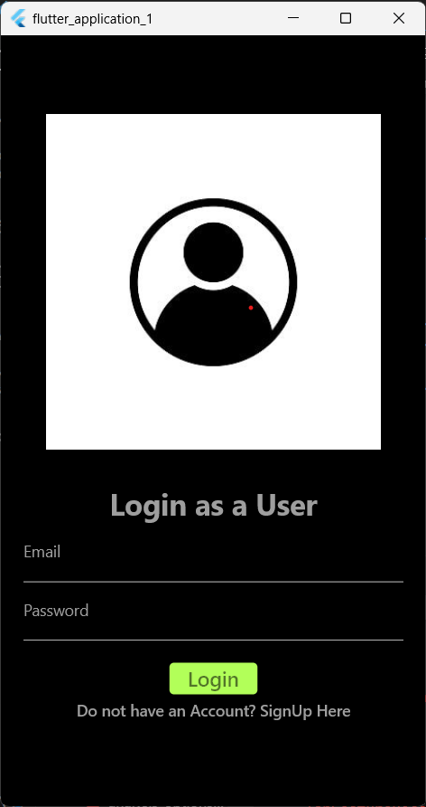

Code Snippet:
void signIn() async {
if (emailTextEditingController.text.isNotEmpty &&
passwordTextEditingController.text.isNotEmpty) {
var reqBody = {
"email": emailTextEditingController.text,
"password": passwordTextEditingController.text
};
var response = await http.post(Uri.parse(loginUrl),
headers: {"Content-Type": "application/json"},
body: jsonEncode(reqBody));
var jsonResponse = jsonDecode(response.body);

if (jsonResponse['status']) {
var myToken = jsonResponse['token'];
prefs.setString('token', myToken);

if (emailTextEditingController.text == 'zoyanaveed53@gmail.com') {
// Redirect to a different page for the specified user
Navigator.push(
context,
MaterialPageRoute(builder: (context) => HomePage(token: myToken)),
);
} else {
// Redirect to the default home page
Navigator.push(
context,
MaterialPageRoute(
builder: (context) => StudentMainScreen(token: myToken)),
);
}

// Navigator.push(context,
// MaterialPageRoute(builder: (context) => HomePage(token: myToken)));
} else {
print('Something went wrong');
}
}
}
}

- Sign Up Page:
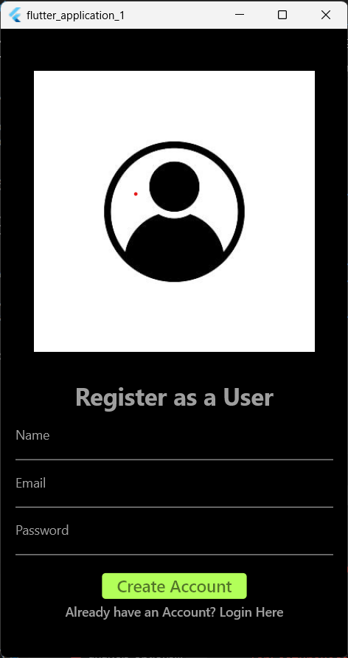

CodeSnippet:
validateForm() {
if (nameTextEditingController.text.length < 3) {
showToast(message: "Username should atleast be three characters long");
} else if (!emailTextEditingController.text.contains("@")) {
showToast(message: "Email address is not Valid.");
} else if (passwordTextEditingController.text.length < 6) {
showToast(message: "Password must be atleast 6 Characters.");
} else {
signUp();
}
}

void signUp() async {
if (nameTextEditingController.text.isNotEmpty &&
passwordTextEditingController.text.isNotEmpty &&
passwordTextEditingController.text.isNotEmpty) {
var regBody = {
"username": nameTextEditingController.text,
"email": emailTextEditingController.text,
"password": passwordTextEditingController.text
};
var response = await http.post(Uri.parse(registerationUrl),
headers: {"Content-Type": "application/json"},
body: jsonEncode(regBody));

var jsonResponse = jsonDecode(response.body);

print(jsonResponse['status']);

if (jsonResponse['status']) {
Navigator.push(
context, MaterialPageRoute(builder: (context) => LoginPage()));
} else {
print("SomeThing Went Wrong");
}
} else {
setState(() {
isNotValidate = true;
});
}
}

- Student Assignments Page:
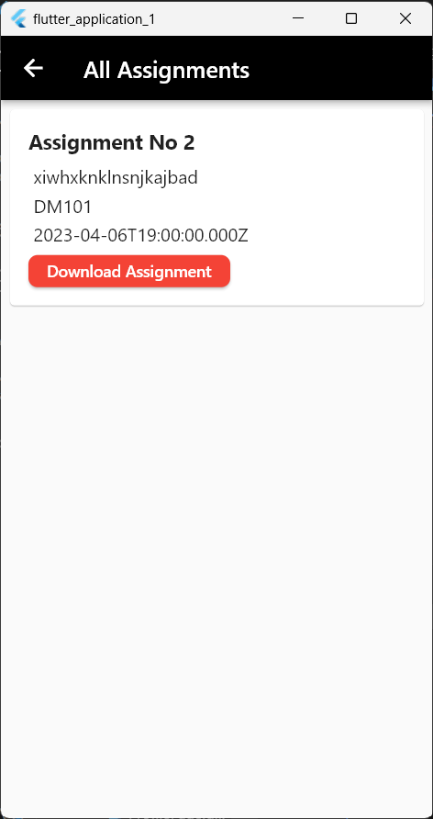

Code Snippet:
Future<void> downloadAssignment(String assignmentId) async {
final response =
await http.get(Uri.parse('$assignmentsUrl/$assignmentId/download'));
if (response.statusCode == 200) {
// Get the documents directory using path_provider
Directory appDocDir = await getApplicationDocumentsDirectory();
String filePath =
'${appDocDir.path}/downloaded_file.pdf'; // You can change the file name and extension
// Write the file
File file = File(filePath);
await file.writeAsBytes(response.bodyBytes);

// Open the file using the default platform mechanism
OpenFile.open(filePath);
} else {
// Handle error
print('Failed to download file: ${response.statusCode}');
}
- Admin Add courses Page:
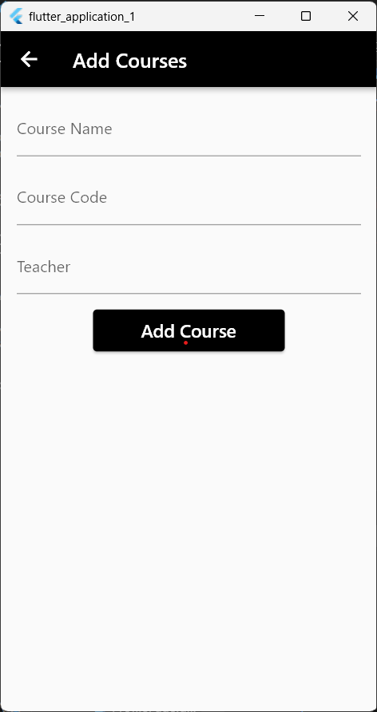

Code Snippet:
Future<void> _addCourse() async {
try {
if (_courseNameController.text.isNotEmpty &&
_courseCodeController.text.isNotEmpty &&
_teacherController.text.isNotEmpty) {
var regBody = {
"name": _courseNameController.text,
"code": _courseCodeController.text,
"teacher": _teacherController.text
};
var response = await http.post(Uri.parse(coursesurl),
headers: {"Content-Type": "application/json"},
body: jsonEncode(regBody));
if (response.statusCode == 201) {
// Course added successfully
print('Course added successfully');
Navigator.push(
context, MaterialPageRoute(builder: (c) => CoursesPage()));
}
}
} catch (error) {
// Handle any exceptions that occur during the HTTP request
print('Error adding course: $error');
}
}

- Admin Upload Fee Challan Page:
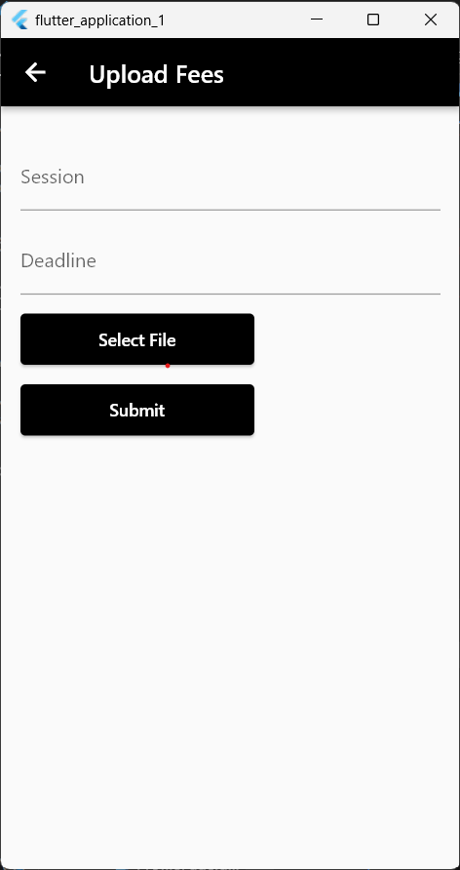
Code Snippet:
Future<void> _submitForm() async {
if (_formKey.currentState!.validate()) {
String session = _sessionController.text;
String deadline = _deadlineController.text;

// Assuming you have an API endpoint to handle assignment creation
var apiUrl = Uri.parse(feesUrl);

var request = http.MultipartRequest("POST", apiUrl)
..fields['session'] = session
..fields['deadline'] = deadline
..files.add(http.MultipartFile.fromBytes(
'content', await _selectedFile.readAsBytes(),
filename: _selectedFile.path.split("/").last));

var response = await request.send();

if (response.statusCode == 201) {
// Assignment created successfully
print("Fees Uploaded successfully");
Navigator.push(context, MaterialPageRoute(builder: (c) => FeesPage()));
} else {
// Handle error
print("Failed to upload Fees. Status code: ${response.statusCode}");
}
}
}

